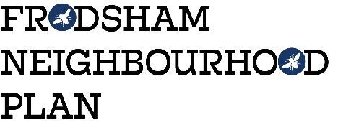 CALL FOR SITES – Application Form
1 | Title
2 | FIRST NAME
3 | SURNAME
4 | COMPANY NAME/AGENCY
5 | Address 1
6 | Address 2
7 | Address 3
8 | Address 4
9 | Address 5
10 | Postcode
11 | Tel Number (Landline)
12 | Company Mobile
13 | Personal Mobile
14 | Company Email
15 | Personal Email
16 | Website

17 | Site Address & Map Grid Ref

18 | Size of the proposed site (in hectares) with a diagram or map highlighting the boundaries for this application.  (Please attach separate sheets with maps/diagrams or scan and attach Word/PDF docs for each application.)

19 | A clear statement about the type of development you wish the land to be considered for e.g. commercial, community facilities, employment, housing (including self-build and affordable housing), leisure, play or activity areas, retail, or tourism etc.
20 | When will the land become available?  e.g. 0-3 years, 3-6 years,  6-10 years, 10 years plus

21 | Please indicate the potential benefit(s) to Frodsham if the proposed site was developed.

22 | Any other supporting information.

Data Protection/Confidentiality. The information that you submit to us will only be shared with the members of the FNP Steering Group and the Independent Planning Specialist who has been assigned to work with us. The information will remain confidential to this group until the FNP has been drafted and the opinions of the local community have been sought (Oct 2018). At this point your name (or agents name) and your proposed site will enter the public domain. In submitting your form, you accept these terms and conditions.  The deadline for ALL applications is: 18.00 on Friday 4th May 2018 | Your signature:  ......................................................................................

